USER Manual V2.0

User manual for C-TSEMMthe Cattle TSE Monitoring Model

28/06/2013

Amie Adkin, Robin Simons and Mark Arnold

Animal Health and Veterinary Laboratories Agency (AHVLA), Weybridge, UK

Summary

This is the user manual produced within project CFT/EFSA/BIOHAZ/2011/02 to accompany the C-TSEMM (the Cattle TSE Monitoring Model). This model has been developed, supported by a user-friendly interface, to evaluate different BSE monitoring regimes in cattle, by estimating the trend of the current BSE epidemic within Member States (MSs). The C-TSEMM uses individual MS standing population, BSE test positive data, and the number of animals tested between 2001 and the current, divided into four exit streams (healthy slaughtered animals, emergency slaughtered animals, fallen stock and clinical suspects).

This manual describes how to install the package, run the model and the user selection of alternative parameters and monitoring regimes through a user-friendly interface.

Table of contents

1 C-TSEMM installation 3

2 User Start 3

2.1 Country information 4

2.2 Parameters 5

2.3 Strains 6

2.4 Sample 6

2.5 Sensitivity 8

2.6 Time taken to detect re-emergence 9

2.7 Baseline 12

2.8 Scenario 13

2.9 Run 14

3 R model files 15

4 R library 16

5 Output data files 16

6 Input data files 20

6.1 Workbook “Consolidated DDMMYY” 20

6.1.1 Adding in additional countries 21

6.1.2 Adding in additional years 21

A. Appendix: Description of outputs 22

1 C-TSEMM installation

In order to install C-TSEMM the software requires Excel 2010 or Excel 2007 to be available on the machine. C-TSEMM has been supplied on disk. To install the package, move or save all files to the C drive of the computer. It is important not to add the package into a folder at this time. In order for the correct functioning of the hard coding the direct location must be C:\C-TSEMM. There are five folders within the package, as shown in Figure 1:

* Input Data Files - containing the input data such as number of test positives in a MS.
* Output Data Files – where the outputs of the model are stored.
* R libraries – contains a version of R 2.14.1 and R libraries needed to run the model.
* R Model files – contains the R model files and model generated inputs (such as EU8/EU17/EU25 estimates for use in MSs with no test positive data).
* User Start – contains the User Interface and User Log.

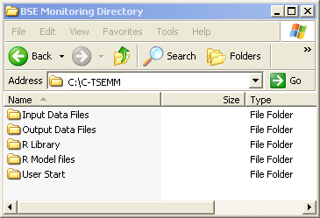

**Figure 1:** C-TSEMM Directory

The following sections describe the contents of each of these folders in detail.

2 User Start

The user interface has been developed in VBA using Excel 2010 as the application, a standard user form and associated macros. Excel VBA was selected due to its stability between machines and the assumption that all users’ computers would have Excel 2007 or Excel 2010 installed in any prior standard Microsoft Office installation.

The “User Start” folder contains the user interface C:\C-TSEMM\User Start\. This is an Excel file with macros enabled. Macros must be enabled for the use of the form. Upon opening the user interface file a standard user form is initiated. The user form has tabs for each of the selections allowing the user to input relevant data and define the precise monitoring regime to be investigated. The form is also used to load relevant data into R and its libraries and run the bespoke C-TSEMM. The file is NOT PROTECTED and therefore there is easy access to view the form code and macros. This flexibility does have the disadvantage that it is easy to amend the form which may affect its functioning. An original copy of the form should be retained.

There are two additional files in the User Start folder which are used for the correct functioning of the user interface. C:\C-TSEMM\User Start\User log.csv is a CSV file where the selections made by the user are automatically read into the R model. This file does not need to be amended. Finally, there is a GIF file (C:\C-TSEMM\User Start\temp.GIF) used to update the graphics within the user interface. This file does not need to be amended.

Each of the user form tabs are described in more detail in each of the following sections.

2.1 Country information

The first tab of the user form enables users to select an individual MS or defined group (EU25). On the Left Hand Side (LHS) of the tab is the list of countries to be selected. On the Right Hand Side (RHS) is the option to run those countries selected separately or as a merged unit as shown in Figure 2.

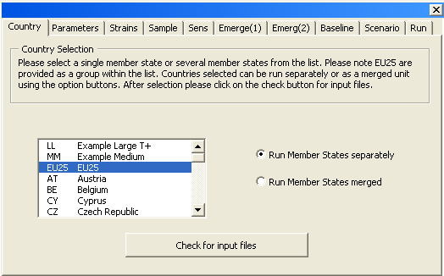

**Figure 2:** Monitoring user form: country information

Once selection has been made the user is requested to click the button at the bottom of the tab “Check for input files”. Checks are made to ensure the user is happy with MSs selected and an error is generated if no MSs are selected. An error message returns if the user has selected both the EU25 and another EU25 country. Finally, a check is made that the input files are present at the correct location C:\C-TSEMM\Input Data Files. Each country is checked in sequence. For example, input files for all EU25 MSs are available, however, files for Bulgaria (BG) are not. If input data are not present, the database Consolidated found in folder C:\C-TSEMM\Input Data Files\ is opened. Please refer to section 6.1.1 of the user manual for instructions to input additional countries data.

Please note that not all user defined combinations of MS/parameter values/strain type will be able to converge. When the model does not converge files will not be returned.

2.2 Parameters

The form permits user defined parameters to be selected and reads this information into the R model so that those values are read in for that simulation run. Parameters which can be changed from a default setting are as follows:

* Age at Onset – default values are based on analysis of the specific strain, and country specific differences for UK simulations. The user can define the two parameters mu and sigma as shown in Figure 3.
* Test Sensitivity – default values based on the analysis in Arnold et al., 2007 or user defined α and β.

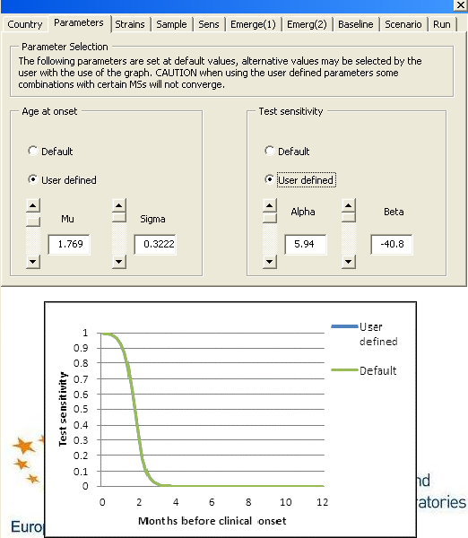

**Figure 3:** Monitoring user form: parameters tab

A graphical display has been developed to enable direct comparison between the default values and user defined values for both age at onset and test sensitivity. To amend the values the user can either directly input values mu and sigma or use the bar sliders beside those text boxes. Note that while any values can be directly input to use in the model, the graphical display only works when using the sliders. If unrealistic values are entered then the model may not successfully converge.

**Infected animals**: In the model we calculate two different types of infected animals, for use in different outputs; *clinically infected* and *all infected*. Clinically infected animals are all animals that the model predicts will be showing clinical signs at any given time, while total infected includes animals that are not yet showing clinical signs. Both groups of animals may be useful as an indicator when considering the effectiveness of surveillance.

2.3 Strains

In recent years, strain typing has enabled differentiation of samples into classical BSE, L and H types. Samples that have not been typed by strain are called “unknown”. The strains tab permits model runs using the different strain data as shown in the drop down menu in Figure 4. Simulations can be run on L type and H type data although there are very few cases except for a few countries such as France and merged datasets such as the EU25.

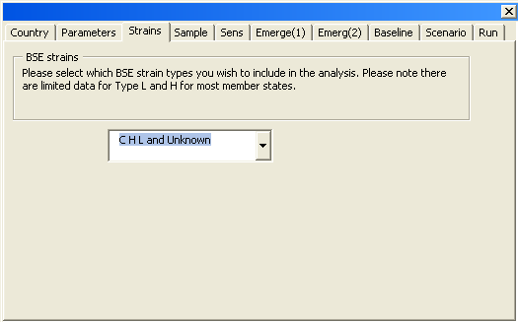

**Figure 4:** Monitoring user form: strains tab

2.4 Sample

The model can estimate the prevalence a monitoring regime can detect based on the sampling of the four testing streams (healthy slaughter, emergency slaughter, fallen stock and clinical suspects) or alternatively the number of animals to be sampled in certain streams to achieve a target design prevalence with a specified value of confidence both specified by the user), as shown in Figure 5.

The first option is to estimate the ‘design prevalence’ achieved by a user defined monitoring system, based on specifying all four streams. The testing to be conducted is specified by the user on the baseline tab. In this way a current or theoretical monitoring system can be evaluated as to the power of detection that is currently being achieved based on a defined level of confidence. If the user selects this output for the EU25, the following output files are created:

* EU25BaselineDp() the number of animals to be tested by each exit stream under the testing regime (baseline or scenario), using the estimated prevalence (detectable or infection) of the population of interest (tested or standing population) given *τ* confidence.
* BaselineDp(tau) a summary of the above files for all countries selected in that run of the number of healthy slaughter animals tested under baseline testing, estimated detectable prevalence of baseline regime, using both the test and standing population and the estimated infection prevalence (clinical) of baseline regime, using the test population, given *τ* confidence. This file also contains the same information for the scenario testing regime.

The second option is that, given fixed monitoring controls on three streams, the model can estimate the sample size required for the fourth stream to achieve a design prevalence of 1 in X to a specified confidence value, *τ*. For example, a design prevalence of 1 in 100,000 may be selected with a confidence value of *τ* =95%. Again the calculation is carried out on the user selections for the baseline tab within the user form. If the user selects this output for the EU25, the following output files are created:

* EU25NumberToTest() estimated number to test for testing regime (baseline or scenario) to detect design prevalence (detectable or infection) of the population of interest (tested or standing population) for each of the streams HS, ES, FS, and CS *given other streams tested*.
* NumberToTest(tau) a summary of the above files for the healthy slaughter outputs for all countries selected in that run of the number of HS tested under baseline testing, estimated number to test for detectable prevalence, using both the test population and the standing population, and infection prevalence (clinical), using the test population, *given other streams tested*. This file also contains the same information for the scenario testing regime (Note that if no HS are tested in the scenario regime, then these results are invalid and the scenario results will say “#NAME?”)

The user can select the desired design prevalence from 1 in 100,000 (default), 1 in 10,000 and 1 in 1,000 and the degree of confidence in the output estimates from 0.95 (default), 0.925 and 0.975.

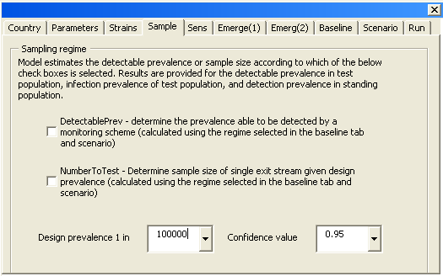

**Figure 5:** Monitoring user form: sample tab

2.5 Sensitivity

C-TSEMM also includes analyses to estimate the overall sensitivity of a monitoring regime, in terms of the number of animals the monitoring regime is able to detect and those that are infected but missed by surveillance. Figure 6 displays the two check boxes on the output tab for selecting additional outputs with the first providing summary results in terms of all streams. The first check box uses the number of clinically infected animals missed by surveillance, while the second check box uses all infected animals missed by surveillance

By selecting the first check box as shown in Figure 6, the model compares estimates of the number of animals detected over one year between a monitoring baseline regime and scenario, for example, the number of test positives animals missed if there is a reduction in the number of animals tested. If the user selects this output for the EU25, the following output files are created:

* EU25numMissed comparison of the model estimated number of baseline and scenario cases detected (those animals which are tested by the regime and test positive), the total number of clinically infected animals slaughtered/dead in one year (regardless of the monitoring regime) and the number of clinically infected animals slaughtered/dead in one year within the age grouping of those tested for the scenario. Confidence intervals are provided on all these outputs.
* NumberMissed a summary of the above file for all countries selected in that run for the actual number tested positive by stream, model estimated baseline cases detected, model estimated scenario cases detected, total number infected (clinical) per year, and the number infected (clinical) in scenario testing regime.

The total number of clinically infected animals is independent of the monitoring regime applied. C-TSEMM also outputs the number infected (clinical) in the scenario testing regime, which is a subset of the total infected only including animals that are tested under the scenario. For example, if the scenario regime includes no healthy slaughter testing, but with testing >48 months ES and FS, with all CS tested, the number of model scenario infected is the summed infected (clinical) animals within those age ranges and streams that are tested (>48 months ES and FS, plus all CS).

The second check box stratifies the number of animals infected (all) and missed by surveillance for healthy slaughter and emergency slaughter by age at slaughter on a birth cohort basis or age at slaughter basis as determined by the user. This stratified output has been provided for use in food chain related risk assessments where the age of all infected cattle at death at entry into the food chain is an important input. Additionally the user can choose whether the analysis is carried out with the current baseline year data (baseline year only) or whether the analysis is carried out retrospectively (for previous years) for a historical analysis.

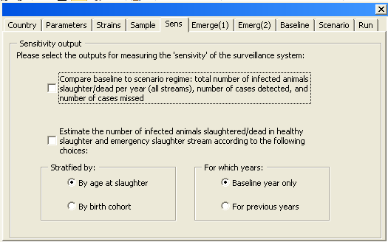

**Figure 6:** Monitoring user form: sensitivity tab

2.6 Time taken to detect re-emergence

Estimates can be produced for the length of time taken to detect a statistically significant increase in the number of cases observed, together with the number of cases which would be detected during this interval and the number of infected animals. An increasing prevalence per year is required for this analysis, either selected from the drop down list of 3%, 10% or 20%, or defined by the user. Figure 7 displays the user options for the proposed trend in prevalence.

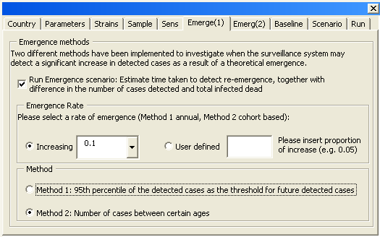

**Figure 7:** Monitoring user form: Emergence (1) tab

As shown in Figure 7, at the bottom of the Emergence (1) tab the user has the option to select one of two methods.To calculate the number missed, method 1 uses clinically infected animals while method 2 uses all infected animals

**Method 1**

This method implements the increase as a flat increase over all animals each year and uses the 95th percentile of the detected cases as the threshold number of cases required in a future year for the increase to be observed. If the user selects this output for the EU25, the following output files are created:

* EU25Emergence comparison of the model estimated number of years to cross upper limit for baseline and scenario, difference in the number of test positive animals detected by baseline and scenario during the time interval between initiation of hypothetical increase and detection, and the difference in the total number of infected (clinical) animals slaughtered/dead during the time interval between initiation of hypothetical increase and detection.
* Emergence(strain type) a summary of the above file for all countries selected for the number of years to cross upper limit, difference in the number of test positives at detection, and the difference in the number of infected animals (clinical) at detection between the baseline regime and scenario.

**Method 2**

This method implements the increase only in the birth cohort of animals born in that year, by extending the exponential trend from the main model into future years, allowing for the increasing trend. This extended trend is used to estimate the expected number of animals infected (all) and cases detected. The threshold number of cases required for the increase to be observed is defined by the user (refer to Figure 8). Additionally, the user is able to specify an ‘age window’ in which the detected cases must fall, In Figure 8 the user has chosen that 2 cases must be detected in animals aged between 48 -72 months. The user can also specify whether the split of animals into individual streams (from HSES and CSFS combined streams) should be based on data from 2002-2011, 2002-2004 or 2008-2011. Simulation of 10,000 datasets of detected cases by age group and year are generated to account for Poisson variability about the expected values and the year of detection is calculated for each. The expected (or average) year of detection is defined as the mean over all the simulations. The lower and upper confidence limits are the 2.5th and 97.5th percentiles respectively. If the user selects this output for EU25 and runs the model on 28.06.13 then the following outputs are created:

* A folder called Emer2013 located C:\C-TSEMM\Output Data Files\28.06.13\EU25 where Method 2 files are placed.
  + EU25timeToDet, a summary output detailing the baseline and scenario runs Expected (Average), lower CI and upper CI number of years to detection (i.e. the year in which the increase is observed) as well as confirming the user inputs for the number of cases needed for detection, the start and end ages of the “age window”, the rate of increase and the method for division into the individual streams.
  + EU25nMissEmerbase & EU25nMissEmerscen: summary files detailing the number of animals missed (i.e. number of all infected animals – number of detected animals). Lower CI and upper CI years of detection and the total number of animals missed. Note that the lower confidence interval of the year could be at a time when there is an increasing trend in younger animals but still a decreasing trend from the previous outbreak in older animals. In these cases the upper CI of number missed in the year of detection for those older animals will actually be higher than the lower CI and are replaced with NaNs
* Sub folders called *base* and *scen* which contain detailed results of the number of detected cases, EU25nDetEmer[stream](run), infected animals, EU25nDetEmer[stream](run), and number missed, EU25nMissed[stream](run), for each age category in each year for the baseline and scenario runs respectively, as well as a file called EU25totByYr(run) which contains sums over all ages of the detected cases, all infected animals and number missed for each year up to the average year of detection.

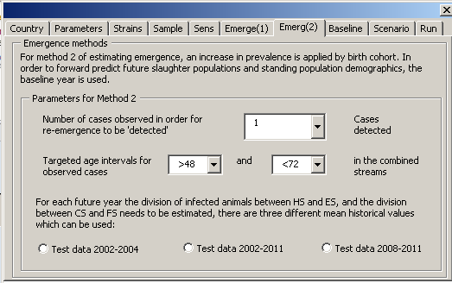

**Figure 8:** Monitoring user form: Emergence (2) tab

2.7 Baseline

The baseline tab permits the user to enter criteria to define the baseline monitoring regime for each of the four exit streams. The baseline scenario for the model is shown in Figure 9, that is, 100% healthy slaughter testing from >72 months of age, 100% emergency slaughter and fallen stock testing from 48 months of age, and the testing of all clinical suspects.

The baseline regime selected by the user is required to estimate the prevalence the scheme can detect or alternatively the number of animals to be sampled in certain streams to achieve a target design prevalence (refer to testing tab in section 2.3).

For each stream the age (months) above which testing is conducted (increments of 12 months) can be changed. There is also the option to insert an end age to testing where a ‘window’ of monitoring is being investigated. Finally, a percentage of testing is also available (increments of 1%). Where no testing in a stream is required, the Percentage (%) testing for that stream should be set to 0. Note that, while it is technically possible to directly input alternative values in the start and end age boxes, the model will only run if values from the drop down boxes are selected. For the percentage tested, the model will work on any plausible value between 0 and 1.

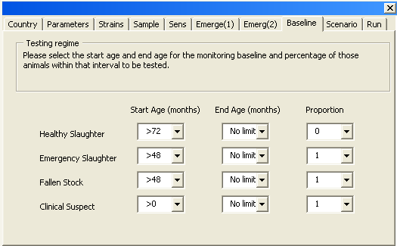

**Figure 9:** Monitoring user form: baseline tab

2.8 Scenario

The scenario tab permits the user to enter a comparison monitoring regime to the baseline for use in estimating the number of animals missed and the time taken to detect a re-emergence (refer to outputs tab section 2.4). An example is shown in Figure 10 of the monitoring scenario for no healthy slaughter testing, 100% testing of emergency slaughter and fallen stock > 48 months, and all clinical suspects tested.

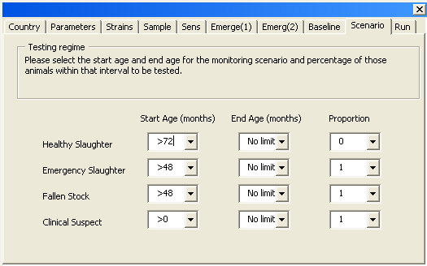

**Figure 10:** Monitoring user form: scenario tab

2.9 Run

The final tab on the user form is used to save the selections made and initialise the R script. Once the R model is simulating, a new Window opens the Output Data Files folder where the results will be saved and the user can then open the relevant output files. The User Interface automatically closes once R is running. It is important to wait whilst the model is working; the current run time is dependent on the computer processor speed, with a minimum run time of approximately 2 minutes for all 25 MSs.

A check box is provided at the bottom of the run tab to output specific validation graphs and tables. These graphs and tables are not routinely required as outputs of the model but have been created to investigate the model fitting process and provide other validation points during development. The Run tab is shown in Figure 11.

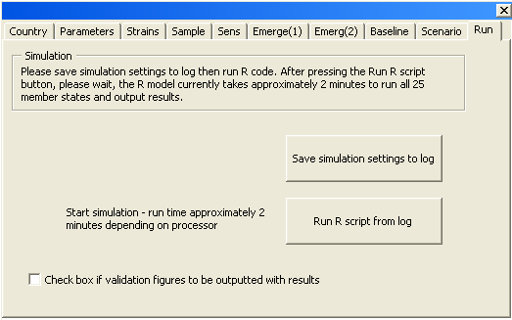

**Figure 11:** Monitoring user form: run tab

3 R model files

The folder C:\C-TSEMM\R Model files contains the bespoke R model created which implements the model calculations. These files can be amended by a technical expert. Note that the main R model file (mainBSE_v1), has no file type and should not be confused with the file of the same name of type ROUT, which is an output file generated by R during model calculations. This folder also contains model generated CSV files, which are used within the model.

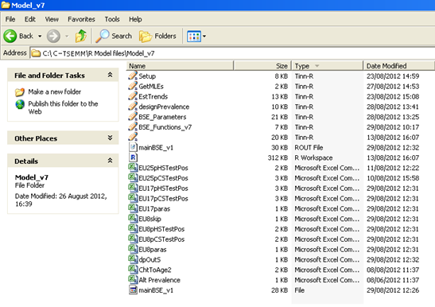

**Figure 12:** R Model folder

4 R library

The folder C:\C-TSEMM\R Library contains the version of R (R-2.14.1) that is compatible with the bespoke R programme and contains all software required for its operation.

5 Output data files

The outputs selected by the user are located in C:\C-TSEMM\Output Data Files with version control in place on a per country folder basis with the initial folder by date. A detailed description of each of the model output files is provided in the Appendix to this report. The model will create a folder with today’s date to store the results, refer to Figure 13.

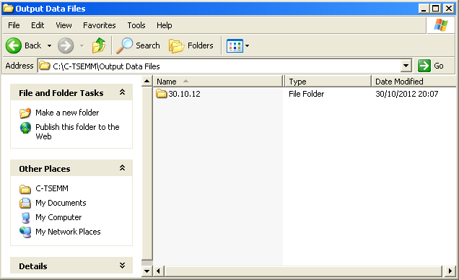

**Figure 13**: Output Data Files: main dated file folder

Figure 14 shows an example of outputs in a dated file folder. Within this folder are stored the summary output files for the entire run and separate folders are created to store the MS specific outputs. If multiple runs occur on the same day, results are distinguished by version numbers (output_v2, output_v3, etc…). The names of the summary BaselineDp and summary NumberToTest output files also include the value of *τ* used for that run. The name of the summary Emergence output file includes the strain type.

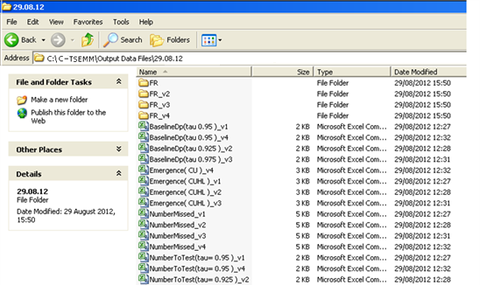

**Figure 14**: Output Data Files: Today’s data directory

Within the MS folder are outputs for that specific MS and a validation folder, as shown in Figure 15 for EU25 merged data. The BaselineDp name includes whether the outputs are baseline/scenario, detectable (det) or clinical infection (inf) prevalence, for the tested population or standing population.

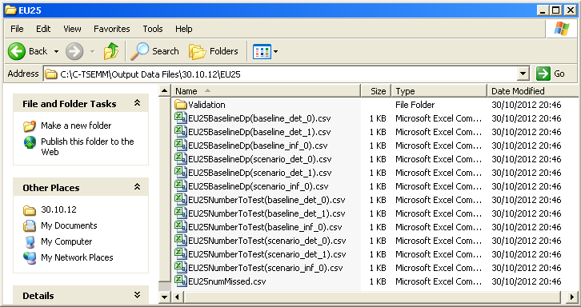

**Figure 15**: Output Data Files: MS folder

The validation folder is used to store descriptive outputs to compare the goodness of fit of the model and is shown in Figure 16. These include figures of the model fit for different streams provided to scale and for the log10 of the number of observed cases and model estimated cases. The logged data are provided to give a clearer idea of the goodness of fit at low values. The figures are outputted as PNG images to economise on file storage size.

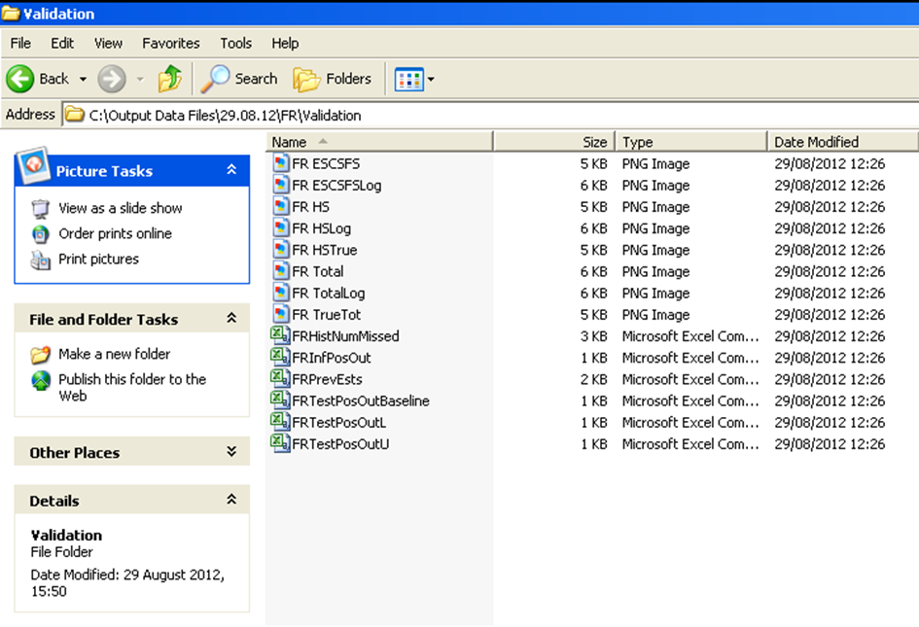

**Figure 16**: Output Data Files: validation folder

If the user selects the validated output for the EU25, the following validation files are outputted:

Output graphs:

* EU25 ESCSFS, EU25 HS, EU25 Total output graphs by exit stream in title for the observed number of test positive and model estimated number of test positive cases, together with Poisson confidence intervals.
* EU25 ESCSFSLog, EU25 HSLog, EU25 TotalLog. As above but the data are presented using log base 10 (one added to prevent error of zero)
* EU25 HSTrue, EU25 TrueTot output graphs by exit stream in title for the observed number of test positive and model estimated true prevalence, together with Poisson confidence intervals.

Output workbooks:

* EU25HistNumMissed a historical comparison (2002-2011) of the model mean estimated number of baseline and scenario cases detected (those animals which are tested by the regime and test positive), the total number of all infected animals slaughtered/dead per year (regardless of the monitoring regime) and the number of all infected animals slaughtered/dead per year. Confidence intervals are provided for each output.
* EU25InfPosOut a historical comparison (2002-2011) of model mean estimated number of clinically infected animals by exit stream for each surveillance year.
* EU25PreEsts a historical comparison (1991-2011) of model mean estimated test prevalence and true prevalence by birth cohort with upper and lower confidence intervals.
* EU25TestPosOutBaseline a historical comparison (2002-2011) of model mean estimated test positive animals and observed test positive animals by exit stream.
* EU25TestPosOutL a historical comparison (2002-2011) of model lower confidence interval estimated test positive animals by exit stream.
* EU25TestPosOutU a historical comparison (2002-2011) of model upper confidence interval estimated test positive animals by exit stream.

6 Input data files

The folder “Input Data Files” C:\C-TSEMM \Input Data Files contains all input data required to run C-TSEMM:

* Consolidated DDMMYY Excel file with macros enabled
* Number dead CSV files by member state and exit stream
* Number tested CSV files by member state and exit stream
* Test positive CSV files by member state, exit stream and strain
* Standing population CSV files by member state.

6.1 Workbook “Consolidated DDMMYY”

The input database in Excel 2010 has been compiled from the data supplied by EFSA, Eurostat, and from a questionnaire completed by MSs. The file name is “Consolidated DDMMYY” and contains a worksheet for every country to be covered by the model together with EU25, EU8 and EU17 merged files. Macros must be enabled for the proper functioning of this Excel workbook.

The remaining folders within the Input Data Files (standing population, number dead, number tested, and test positive) are automatically generated by this database. It is important that data updates and changes are made within the Consolidated workbook and not the individual csv read-in files.

The first worksheet named “Register” provides a register of the data present for each MS. The EU25 dataset only is complete. An additional worksheet named “Exit%” has been added to centralise any assumptions made due to the presence of data gaps (refer to the main C-TSEMM model report for details). Additional worksheets can be added to this file, which requires the same format as those already present. Due to the hard coding of macros it is important not to add or remove columns and rows from any worksheets except “Register”.

From this master database all MS specific files can be generated automatically using the macro called “MakeCSV”. This can be activated by (1) clicking the button on the tab Register to “Create/update input files”, or (2) by clicking on the Developer Tab – Macros button on main ribbon – Run button on Macro dialogue box.

The macro copies each table by MS needed by the model and saves as a separate Comma Separated Value (CSV) file ready for reading into the R model component. This produces the following files: Standing Population (28), Number Dead (28), Number Tested (112), and Test Positive (448). The macro automatically overwrites any files present within those named folders.

6.1.1 Adding in additional countries

New countries can be analysed using C-TSEMM given that all the input data are available, however, adjustments are required where there is little case data.

A blank sheet denoted “OO” can be copied with the tab renamed with the standard accepted acronym of that territory. All data tables should be filled in. Where no animals have been tested or tested positive, zero values should be inputted rather than remaining blank. Due to the hard coding of macros it is important not to add or remove columns and rows from any worksheets. Once the country data has been inputted into a worksheet, the sheet needs to be named by the standard accepted acronym on the tab. The CSV input files for that country can then be automatically created by pressing the “Create/update input files” button on the Register tab.

Once the CSV input files have been created the R code will automatically attempt to run the newly created files when that territory is selected from the User Interface Country tab drop down menu. The interface will also check that the new files have been saved in the correct folders.

There is one modification which will need to be made if there are few or no test positives. For those countries with no or limited test positive data the prevalence of the EU25, EU17 or EU8 is used as a surrogate. This is detailed in the model file C:\C-TSEMM\R Model files\Model_v7\Alt Prevalence.csv. Within this folder the surrogate estimate for prevalence must be named. For example, Malta has no test positive data and therefore EU8 is listed alongside this MS.

When determining whether a country has too few test positive data, the R model should be run on the countries data to start. This could result in two different eventualities. Firstly, no output files may be generated. In this case, the R model could not converge on any output and no files are produced. In these cases an alternative prevalence needs to be specified. Secondly, output files may be produced and the validation files, generated by checking the box on the bottom of the Run tab, should be viewed. By comparing the model estimates and confidence intervals with the observed cases for that country, the fit of the model can be estimated. If the model estimates and observed cases are of a poor fit, an alternative surrogate for prevalence may be required.

6.1.2 Adding in additional years

Space for additional years 2012, 2013 and 2014 have been supplied within the workbook. Once all the additional information has been entered, the input files for those years for that country can be automatically created by pressing the “Create/update input files” button on the Register tab.

1. Appendix: Description of outputs

|  |  |
| --- | --- |
| Name | BaselineDp(tau) |
| Location | In dated folder |
| Explanation | A summary of MS specific outputs for all countries selected in that run with level of confidence (tau) denoted in brackets. The file provides the actual number of HS tested, together with the model estimated prevalence a monitoring regime can detect for a given *τ* (tau) confidence. Baseline testing results are provided as well as those for a scenario regime if defined by the user. Results are provided for the detectable prevalence in test population, infection prevalence of test population, and detection prevalence in standing population. |
| Actual number HS tested | Actual number of healthy slaughter (HS) animals tested as detailed in Consolidated dataset. |
| Estimated baseline detectable prevalence, tau= | Model estimated *detectable* prevalence (1 in X) that the *baseline* monitoring regime is able to detect in the *tested* population at tau stated, where N/A model did not converge. |
| Estimated baseline infection prevalence, tau= | Model estimated *clinical infection* prevalence (1 in X) that the *baseline* monitoring regime is able to detect in the *tested* population at tau stated, where N/A model did not converge. |
| Estimated standing pop detection prevalence, tau= | Model estimated *detectable* prevalence (1 in X) that the *baseline* monitoring regime is able to detect in the *standing* population at tau stated, where N/A model did not converge. |
| scenarioDetTestPop | Model estimated *detectable* prevalence (1 in X) that the *scenario* monitoring regime is able to detect in the *tested* population at tau stated, where N/A model did not converge. |
| scenarioInfTestPop | Model estimated *clinical infection* prevalence (1 in X) that the *scenario* monitoring regime is able to detect in the *tested* population at tau stated, where N/A model did not converge. |
| scenarioDetStandPop | Model estimated *detectable* prevalence (1 in X) that the *scenario* monitoring regime is able to detect in the *standing* population at tau stated, where N/A model did not converge. |

|  |  |
| --- | --- |
| Name | Emergence( ) |
| Location | In dated folder |
| Explanation | Method 1: A summary of MS specific outputs for all countries selected in that run by strain type denoted in brackets. This file provides a comparison of the model estimated number of years to cross upper limit for baseline and scenario regimes, the difference in the number of test positive animals detected during the time interval between initiation of hypothetical increase and detection, and the difference in the total number of infected animals slaughtered/dead during the time interval between initiation of hypothetical increase and detection. |
| Rate of increase per year (%) | User selected rate of increase of the (re)-emergence. |
| Current number test positives (baseline, scenario) | The model estimated mean number of test positives detected by the monitoring regime with the baseline regime and scenario regime outputs separated by a comma. |
| Upper CI limit ( 0.975 ) | The model estimated 97.5th confidence value of the number of test positives detected by the baseline monitoring regime. |
| Years to cross upper limit (baseline, scenario) | The model estimated number of years for the number of cases to cross upper limit with the baseline regime and scenario regime outputs separated by a comma. |
| Total test positives at detection (baseline, scenario) | The model estimated total number of test positives up to the year when the upper limit is crossed with the baseline regime and scenario regime outputs separated by a comma. |
| Number extra cases under scenario before detection | The total number of test positives at detection for the baseline regime minus the total number of test positives at detection for the scenario regime. A minus value is possible however; generally where a monitoring regime is reduced the scenario regime takes sufficiently long to detect the increase, so that more cases are detected overall. |
| Total infected at detection (baseline, scenario) | The model estimated total number of clinically infected animals from initiation of the (re) emergence to detection with the baseline regime and scenario regime outputs separated by a comma. The total number clinically infected includes those clinically infected animals that would test positive, if tested, and those infected that would test negative, together with those not tested. |
| Number extra infected animals dead before detection (scenario-baseline) | The total number of clinically infected animals dead before detection for the baseline regime minus the total number of infected animals dead before detection for the scenario regime. |

|  |  |
| --- | --- |
| Name | NumberMissed |
| Location | In dated folder |
| Explanation | A summary of MS specific outputs for all countries selected in that run. This file provides the model estimates of the number of animals detected over one year (cases) between a monitoring baseline regime and scenario, for example, the number of test positives animals missed if there is a reduction in the number of animals tested.  Additional outputs are the total number of clinically infected animals slaughtered/dead in one year (regardless of the monitoring regime) and the number of clinically infected animals slaughtered/dead in one year within the age grouping of those tested for the scenario. |
| Actual baseline regime cases 2011 {HS,ES,FS,CS} | Actual number of cases by exit stream as detailed in Consolidated dataset for the most recent year of testing. |
| Model baseline cases [CI] | Model estimated mean number of cases detected for the *baseline* monitoring regime (those animals which are tested by the regime and test positive), together with 95% confidence intervals in brackets. |
| Model scenario cases[CI] | Model estimated mean number of cases detected for the *scenario* monitoring regime (those animals which are tested by the regime and test positive), together with 95% confidence intervals in brackets. |
| Model Number cases missed (baseline-scenario) | Model mean number of cases detected for the baseline monitoring regime minus mean number of cases detected for the scenario monitoring regime, together with 95% confidence intervals in brackets. |
| Model Number Infected (Total data) [CI] | Model estimated number of clinically infected animals (irrespective of monitoring regime) slaughtered/dead in one year including all four exit streams, together with 95% confidence intervals in brackets. The total number clinically infected includes those clinically infected animals that would test positive, if tested, and those infected that would test negative, together with those not tested. |
| Model Scenario Infected [CI] | Model estimated number of clinically infected animals (within the age groups tested for the scenario) slaughtered/dead in one year including all four exit streams, together with 95% confidence intervals in brackets. For example, if the scenario regime includes no healthy slaughter testing, but with testing >48 months ES and FS, with all CS tested, the number of model scenario clinically infected is the summed clinically infected animals within those age ranges and streams that are tested (>48 months ES and FS, plus all CS). |

|  |  |
| --- | --- |
| Name | NumberToTest(tau=) |
| Location | In dated folder |
| Explanation | A summary of MS specific outputs for all countries selected in that run with level of confidence (tau) denoted in brackets. Given the testing specified of three of the four exit streams by the user, this file provides the model estimated sample size required for the fourth stream to achieve a design prevalence of 1 in X to a specified confidence value, *τ* *given the other streams are tested*. For example, a design prevalence of 1 in 100,000 may be selected with a confidence value of *τ* =95%. |
| actual number HS tested | Actual number of healthy slaughter (HS) animals tested as detailed in Consolidated dataset. |
| Estimated HS to test for detectable design prevalence, tau= 0.95 | Model estimated number to test using the *detectable* prevalence that the *baseline* monitoring regime is able to detect in the *tested* population at tau stated *given the other streams are tested*, where N/A model did not converge. |
| Estimated HS to test for infection design prevalence, tau= 0.95 | Model estimated number to test using the *clinical infection* prevalence that the *baseline* monitoring regime is able to detect in the *tested* population at tau stated *given the other streams are tested*, where N/A model did not converge. |
| Estimated, standing pop, HS to test for detection design prevalence, tau= 0.95 | Model estimated number to test using the *detectable* prevalence that the *baseline* monitoring regime is able to detect in the *standing* population at tau stated *given the other streams are tested*, where N/A model did not converge. |
| scenarioDetTestPop | Model estimated number to test using the *detectable* prevalence that the *scenario* monitoring regime is able to detect in the *tested* population at tau stated *given the other streams are tested*, where N/A model did not converge. Note that if no HS are tested in the scenario regime, then these results are invalid and the scenario results will say “#NAME?” |
| scenarioInfTestPop | Model estimated number to test using the *clinical infection* prevalence that the *scenario* monitoring regime is able to detect in the *tested* population at tau stated *given the other streams are tested*, where N/A model did not converge. Note that if no HS are tested in the scenario regime, then these results are invalid and the scenario results will say “#NAME?” |
| scenarioDetStandPop | Model estimated number to test using the *detectable* prevalence that the *scenario* monitoring regime is able to detect in the *standing* population at tau stated *given the other streams are tested*, where N/A model did not converge. Note that if no HS are tested in the scenario regime, then these results are invalid and the scenario results will say “#NAME?” |

|  |  |
| --- | --- |
| Name | BaselineDp(baseline_det_#) |
| Location | In country folder, in dated folder |
| Explanation | For country denoted in file name, the model estimated number of healthy slaughter tested under baseline testing using the detectable prevalence in the standing population (1) or tested population (0) given *τ* confidence. |
| baseline 'design prevalence' (expressed as 1 in X) | Model estimated *detectable* prevalence (1 in X) that the *baseline* monitoring regime is able to detect, at tau stated, where N/A model did not converge. |
| observed number tested | Actual number of healthy slaughter (HS) animals tested as detailed in Consolidated dataset. |
| number tested to achieve dp | A validation point providing the number of healthy slaughter (HS) animals tested. This value should equal the value in cell B3 if the model has converged correctly. |

|  |  |
| --- | --- |
| Name | BaselineDp(baseline_inf_0) |
| Location | In country folder, in dated folder |
| Explanation | For country denoted in file name, the model estimated number of healthy slaughter tested under baseline testing using the clinical infection prevalence in the tested population given *τ* confidence. |
| baseline 'design prevalence' (expressed as 1 in X) | Model estimated *clinical* *infection* prevalence (1 in X) that the *baseline* monitoring regime is able to detect in the *tested* population at tau stated, where N/A model did not converge. |
| observed number tested | Actual number of healthy slaughter (HS) animals tested as detailed in Consolidated dataset. |
| number tested to achieve dp | A validation point providing the number of healthy slaughter (HS) animals tested. This value should equal the value in cell B3 if the model has converged correctly. |

|  |  |
| --- | --- |
| Name | BaselineDp(scenario_det_*#*) |
| Location | In country folder, in dated folder |
| Explanation | For country denoted in file name, the model estimated number of healthy slaughter tested under scenario testing using the detection prevalence in the standing population (1) or tested population (0) given *τ* confidence. |
| baseline 'design prevalence' (expressed as 1 in X) | Model estimated *detectable* prevalence (1 in X) that the *scenario* monitoring regime is able to detect, at tau stated, where N/A model did not converge. |
| observed number tested | Number of healthy slaughter (HS) animals tested as detailed in Consolidated dataset and modified by age controls selected by user. |
| number tested to achieve dp | A validation point providing the number of animals tested. This value should equal the value in cell B3 if the model has converged correctly. |

|  |  |
| --- | --- |
| Name | BaselineDp(scenario_inf_0) |
| Location | In country folder, in dated folder |
| Explanation | For country denoted in file name, the model estimated number of healthy slaughter tested under scenario testing using the clinical infection prevalence in the tested population given *τ* confidence. |
| baseline 'design prevalence' (expressed as 1 in X) | Model estimated *clinical* *infection* prevalence (1 in X) that the *scenario* monitoring regime is able to detect in the *tested* population at tau stated, where N/A model did not converge. |
| observed number tested | Number of healthy slaughter (HS) animals tested as detailed in Consolidated dataset and modified by age controls selected by user. |
| number tested to achieve dp | A validation point providing the number of animals tested. This value should equal the value in cell B3 if the model has converged correctly. |

|  |  |
| --- | --- |
| Name | Emergence |
| Location | In country folder, in dated folder |
| Explanation | Method 1: For country denoted in file name, this file provides a comparison of the model estimated number of years to cross upper limit for baseline and scenario regimes, the difference in the number of test positive animals detected during the time interval between initiation of hypothetical increase and detection, and the difference in the total number of clinically infected animals slaughtered/dead during the time interval between initiation of hypothetical increase and detection. |
| Rate of increase per year (%) | User selected rate of increase of the (re)-emergence. |
| Current number test positives (baseline, scenario) | Model estimated mean number of test positives detected by the monitoring regime with the baseline regime and scenario regime outputs separated by a comma. |
| Upper CI limit ( 0.975 ) | Model estimated 97.5th confidence value of the number of test positives detected by the baseline monitoring regime. |
| Years to cross upper limit (baseline, scenario) | Model estimated number of years for the number of cases to cross upper limit with the baseline regime and scenario regime outputs separated by a comma. |
| Total test positives at detection (baseline,scenario) | Model estimated total number of test positives up to the year when the upper limit is crossed with the baseline regime and scenario regime outputs separated by a comma. |
| Number extra cases under scenario before detection | The total number of test positives at detection for the baseline regime minus the total number of test positives at detection for the scenario regime. A minus value is possible however; generally where a monitoring regime is reduced the scenario regime takes sufficiently long to detect the increase, so that more cases are detected overall. |
| Total infected at detection (baseline, scenario) | Model estimated total number of clinically infected animals from initiation of the (re) emergence to detection with the baseline regime and scenario regime outputs separated by a comma. The total number clinically infected includes those clinically infected animals that would test positive, if tested, and those infected that would test negative, together with those not tested. |
| Number extra infected animals dead before detection (scenario-baseline) | The total number of clinically infected animals dead before detection for the baseline regime minus the total number of infected animals dead before detection for the scenario regime. |

|  |  |
| --- | --- |
| Name | EU25timeToDet |
| Location | In Emer2013 folder in country folder, in dated folder |
| Explanation | Summary output detailing for the baseline and scenario runs the Expected (Average), lower CI and upper CI number of years to detection (i.e. when the increase is observed) as well as confirming the user inputs for the number of cases needed for detection, the start and end ages of the Age window, the rate of increase and the method for splitting into the individual streams. |
| Expected number years to detection | Average of the years to detection from the iterations using Poisson variability about the expected number of detected cases |
| Lower Poisson CI number years to detection | 2.5th percentile of the years to detection from the iterations using Poisson variability about the expected number of detected cases |
| Upper Poisson CI number years to detection | 97.5th percentile of the years to detection from the iterations using Poisson variability about the expected number of detected cases |
| Number of cases needed for detection | Confirmation of input from user interface of number of cases needed to be detected in a year to determine that the increasing trend in cases has been observed |
| Start and end ages of animals tested | Confirmation of input from user interface of age window |
| Rate of increase | Confirmation of input from user interface rate of increase per year |
| Split Method | Confirmation of input from user interface for the method of splitting into individual streams |

|  |  |
| --- | --- |
| Name | EU25nMissEmer(run) ,  run= {base, scen} |
| Location | In Emer2013 folder in country folder, in dated folder |
| Explanation | Summary files detailing the number of animals missed (i.e. number of all infected animals – number of detected animals) in the average. Lower CI and upper CI years of detection and the total number of animals missed up to the average. Lower CI and upper CI years of detection, for the baseline and scenario runs respectively. |
| nMissDetYr | Expected number of HS and ES animals missed in the average year of detection |
| nMissDetYrLci | Expected number of HS and ES animals missed in the lower CI year of detection |
| nMissDetYrUci | Expected number of HS and ES animals missed in the upper CI year of detection |
| nMissSum | Expected number of all HS and ES animals missed in all years up to (but not including) the average year of detection |
| nMissSumLci | Expected number of all HS and ES animals missed in all years up to (but not including) the lower CI year of detection |
| nMissSumUci | Expected number of all HS and ES animals missed in all years up to (but not including) the upper CI year of detection |

|  |  |
| --- | --- |
| Name | EU25nDetEmer[stream](run),  stream={HS,ES,CS,FS,HSES,CSFS}, run={base2, scen2} |
| Location | In  *run* folder in Emer2013 folder in country folder, in dated folder |
| Explanation | Files detailing the number of detected cases in stream(s) by age and year after increase |
| Rows | Age group of animals |
| Columns | Year after increase begins. The first column is titled ‘current’ year which is the year before the increase. The second column is titled ‘1’ and is the first year after the increase begins, thus the increase is present in animals aged 0-12 months only. |

|  |  |
| --- | --- |
| Name | EU25nInfEmer[stream](run),  stream={HS,ES,CS,FS, HSES,CSFS }, run={base2, scen2} |
| Location | In  *run* folder in Emer2013 folder in country folder, in dated folder |
| Explanation | Files detailing the number of all infected animals in stream(s) by age and year after increase |
| Rows | Age group of animals |
| Columns | Year after increase begins. The first column is titled ‘current’ year which is the year before the increase. The second column is titled ‘1’ and is the first year after the increase begins, thus the increase is present in animals aged 0-12 months only. |

|  |  |
| --- | --- |
| Name | EU25nMissed[stream](run),  stream={HS,ES,CS,FS, HSES,CSFS }, run={base2, scen2} |
| Location | In  *run* folder in Emer2013 folder in country folder, in dated folder |
| Explanation | Files detailing the number of animals missed by testing (i.e. all infected animals-detected cases) in stream(s) by age and year after increase |
| Rows | Age group of animals |
| Columns | Year after increase begins. The first column is titled ‘current’ year which is the year before the increase. The second column is titled ‘1’ and is the first year after the increase begins, thus the increase is present in animals aged 0-12 months only. |

|  |  |
| --- | --- |
| Name | EU25totByYr(run)  run={base2, scen2} |
| Location | In  *run* folder in Emer2013 folder in country folder, in dated folder |
| Explanation | File detailing totals over all streams and ages of the detected cases, all infected animals and number missed for each year up to the average year of detection. |
| Row 1: Detected | Total number of detected cases in given year |
| Row 2: Infected | Total number of infected animals in given year |
| Row 1: mIssed | Total number missed in given year |
| Columns | Year after increase begins. The first column is titled ‘current’ year which is the year before the increase. The second column is titled ‘1’ and is the first year after the increase begins, thus the increase is present in animals aged 0-12 months only. |

|  |  |
| --- | --- |
| Name | NumberToTest(baseline_det_*#*) |
| Location | In country folder, in dated folder |
| Explanation | For country denoted in file name, given the testing specified of three of the four exit streams by the user in the *baseline* regime, this file provides the model estimated sample size required for the fourth stream to achieve a design prevalence of 1 in X (estimated using the *detectable* prevalence in the standing population (1) or tested population (0)) to a specified confidence value, *τ*. For example, a design prevalence of 1 in 100,000 may be selected with a confidence value of *τ* =95%. |
| Monitoring Scenario | The monitoring regime for each exit stream for the baseline as selected by user. For example, *>72 , 1 , baseline , det* denotes a baseline regime using the detection prevalence for 100% testing of those animals >72 months. |
| Estimated observed prevalence in exit stream (expressed as: 1 in X) | Model estimated observed detectable prevalence in the most recent year of data used. |
| Estimated scaled prevalence in exit stream (expressed as: 1 in X) | Model estimated scaled detectable prevalence of the most recent year of data (i.e. the expected prevalence in the exit stream if the prevalence in the total population was to change to become the design prevalence). Note that if no animals are present in that stream, Inf is denoted. |
| Actual number tested | Actual number of animals tested in each exit stream as detailed in Consolidated dataset. Note that if no animals are present in that stream, Inf is denoted. |
| Number tested to detect design prevalence if other streams are tested as prescribed by user | Model estimated number of animals needed to be tested in each exit stream *given other streams tested* (these are the actual number tested values in the tables for the other streams). |
| Proportion of actual number tested | The proportion of actual number tested row provides the number of animals that are required to be tested in the stream, as a percentage of the current number tested (i.e. a value of 200 indicates that double the number of animals need be tested). Note for divisions where 0 is present, NaN is denoted. |
| Number to test if only this stream tested | Model estimated number of animals needed to be tested in each exit stream *given no other stream tested*. Note that if no animals are present in that stream, “#NAME?” is denoted. |

|  |  |
| --- | --- |
| Name | NumberToTest(baseline_inf_*0*) |
| Location | In country folder, in dated folder |
| Explanation | For country denoted in file name, given the testing specified of three of the four exit streams by the user in the *baseline* regime, this file provides the model estimated sample size required for the fourth stream to achieve a design prevalence of 1 in X (estimated using the *clinical* *infection* prevalence in the *tested* population) to a specified confidence value, *τ*. For example, a design prevalence of 1 in 100,000 may be selected with a confidence value of *τ* =95%. |
| Monitoring Scenario | The monitoring regime for each exit stream for the baseline as selected by user. For example, *>72 , 1 , baseline , inf* denotes a baseline regime using the clinical infection prevalence for 100% testing of those animals >72 months. |
| Estimated observed prevalence in exit stream (expressed as: 1 in X) | Model estimated observed clinical infection prevalence in the *test* population of the most recent year of data used. |
| Estimated scaled prevalence in exit stream (expressed as: 1 in X) | Model estimated scaled clinical infection prevalence in the test population of the most recent year of data (i.e. the expected prevalence in the exit stream if the prevalence in the total population was to change to become the design prevalence). Note that if no animals are present in that stream, Inf is denoted. |
| Actual number tested | Actual number of animals tested in each exit stream as detailed in Consolidated dataset. Note that if no animals are present in that stream, Inf is denoted. |
| Number tested to detect design prevalence if other streams are tested as prescribed by user | Model estimated number of animals needed to be tested in each exit stream *given other streams tested* (these are the actual number tested values in the tables for the other streams). |
| Proportion of actual number tested | The proportion of actual number tested row provides the number of animals that are required to be tested in the stream, as a percentage of the current number tested (i.e. a value of 200 indicates that double the number of animals need be tested). Note for divisions where 0 is present, NaN is denoted. |
| Number to test if only this stream tested | The model estimated number of animals needed to be tested in each exit stream *given no other stream tested*. Note that if no animals are present in that stream, “#NAME?” is denoted. |

|  |  |
| --- | --- |
| Name | NumberToTest(scenario_det_*#*) |
| Location | In country folder, in dated folder |
| Explanation | For country denoted in file name, given the testing specified of three of the four exit streams by the user in the *scenario* regime, this file provides the model estimated sample size required for the fourth stream to achieve a design prevalence of 1 in X (estimated using the *detectable* prevalence in the standing population (1) or tested population (0)) to a specified confidence value, *τ*. For example, a design prevalence of 1 in 100,000 may be selected with a confidence value of *τ* =95%. |
| Monitoring Scenario | The monitoring regime for each exit stream for the scenario regime as selected by user. For example, *>72 , 1 , scenario , det* denotes a scenario regime using the detection prevalence for 100% testing of those animals >72 months. |
| Estimated observed prevalence in exit stream (expressed as: 1 in X) | Model estimated observed detectable prevalence in the most recent year of data used. |
| Estimated scaled prevalence in exit stream (expressed as: 1 in X) | Model estimated scaled detectable prevalence of the most recent year of data (i.e. the expected prevalence in the exit stream if the prevalence in the total population was to change to become the design prevalence). Note that if no animals are present in that stream, Inf is denoted. |
| Actual number tested | Actual number of animals tested in each exit stream as detailed in Consolidated dataset. Note that if no animals are present in that stream, Inf is denoted. |
| Number tested to detect design prevalence if other streams are tested as prescribed by user | Model estimated number of animals needed to be tested in each exit stream *given other streams tested* (these are the actual number tested values in the tables for the other streams). |
| Proportion of actual number tested | The proportion of actual number tested row provides the number of animals that are required to be tested in the stream, as a percentage of the current number tested (i.e. a value of 200 indicates that double the number of animals need be tested). Note for divisions where 0 is present, NaN is denoted. |
| Number to test if only this stream tested | Model estimated number of animals needed to be tested in each exit stream *given no other stream tested*. Note that if no animals are present in that stream, “#NAME?” is denoted. |

|  |  |
| --- | --- |
| Name | NumberToTest(scenario_inf_0) |
| Location | In country folder, in dated folder |
| Explanation | For country denoted in file name, given the testing specified of three of the four exit streams by the user in the *scenario* regime, this file provides the model estimated sample size required for the fourth stream to achieve a design prevalence of 1 in X (estimated using the *clinical infection* prevalence in the *tested* population) to a specified confidence value, *τ*. For example, a design prevalence of 1 in 100,000 may be selected with a confidence value of *τ* =95%. |
| Monitoring Scenario | The monitoring regime for each exit stream for the scenario regime as selected by user. For example, *>72 , 1 , scenario , inf* denotes a scenario regime using the infection prevalence for 100% testing of those animals >72 months. |
| Estimated observed prevalence in exit stream (expressed as: 1 in X) | Model estimated infection prevalence in the *test* population of the most recent year of data used. |
| Estimated scaled prevalence in exit stream (expressed as: 1 in X) | Model estimated scaled clinical infection prevalence in the standing? population of the most recent year of data(i.e. the expected prevalence in the exit stream if the prevalence in the total population was to change to become the design prevalence). Note that if no animals are present in that stream, Inf is denoted. |
| Actual number tested | Actual number of animals tested in each exit stream as detailed in Consolidated dataset. Note that if no animals are present in that stream, Inf is denoted. |
| Number tested to detect design prevalence if other streams are tested as prescribed by user | Model estimated number of animals needed to be tested in each exit stream *given other streams tested* (these are the actual number tested values in the tables for the other streams). |
| Proportion of actual number tested | The proportion of actual number tested row provides the number of animals that are required to be tested in the stream, as a percentage of the current number tested (i.e. a value of 200 indicates that double the number of animals need be tested). Note for divisions where 0 is present, NaN is denoted. |
| Number to test if only this stream tested | Model estimated number of animals needed to be tested in each exit stream *given no other stream tested*. Note that if no animals are present in that stream, “#NAME?” is denoted. |

|  |  |
| --- | --- |
| Name | numMissed |
| Location | In country folder, in dated folder |
| Explanation | For country denoted in file name, this file provides a comparison of the model estimated number of *baseline* and *scenario* cases detected (those animals which are tested by the regime and test positive), the total number of clinically infected animals slaughtered/dead in one year (regardless of the monitoring regime) and the number of clinically infected animals slaughtered/dead in one year within the age grouping of those tested for the scenario. |
| Number of cases detected: Baseline | Model estimated mean number of cases for the *baseline* regime. |
| Number of cases detected: Baseline Lci | Model estimated 2.5th confidence value for the number of cases for the *baseline* regime. |
| Number of cases detected: Baseline Uci | Model estimated 97.5th confidence value for the number of cases for the *baseline* regime. |
| Number of cases detected: Scenario | Model estimated mean number of cases for the *scenario* regime. |
| Number of cases detected: Scenario Lci | Model estimated 2.5th confidence value for the number of cases for the *scenario* regime. |
| Number of cases detected: Scenario Uci | Model estimated 97.5th confidence value for the number of cases for the *scenario* regime. |
| Number of infected animals: Total | Model estimated mean number of clinically infected animals (irrespective of monitoring regime) slaughtered/dead in one year including all four exit streams. The total number clinically infected includes those clinically infected animals that would test positive, if tested, and those infected that would test negative, together with those not tested. |
| Number of infected animals: Total Lci | Model estimated 2.5th confidence value for the number of clinically infected animals (irrespective of monitoring regime) slaughtered/dead in one year including all four exit streams. |
| Number of infected animals: Total Uci | Model estimated 97.5th confidence value for the number of clinically infected animals (irrespective of monitoring regime) slaughtered/dead in one year including all four exit streams. |
| Number of infected animals: Scenario | Model estimated mean number of clinically infected animals (within the age groups tested for the scenario) slaughtered/dead in one year including all four exit streams. |
| Number of infected animals: Scenario Lci | Model estimated 2.5th confidence value for the number of clinically infected animals (within the age groups tested for the scenario) slaughtered/dead in one year including all four exit streams. |
| Number of infected animals: Scenario Uci | Model estimated 97.5th confidence value for the number of clinically infected animals (within the age groups tested for the scenario) slaughtered/dead in one year including all four exit streams. |
| Number cases missed (baseline-scenario) | Mean number of cases detected for the baseline monitoring regime minus mean number of cases detected for the scenario monitoring regime. |
| Number infected missed (total-scenario)) | Mean number of clinically infected animals (total of all ages) slaughtered/dead in one year including all four exit streams minus the mean number of infected animals (within the age groups tested for the scenario) slaughtered/dead in one year including all four exit streams. |

|  |  |
| --- | --- |
| Name | Graph: ESCSFS, HS, Total |
| Location | Validation folder, in country folder, in dated folder |
| Explanation | For country and exit streams denoted in file name, output graphs for the observed number of test positive and model estimated number of test positive cases, together with Poisson confidence intervals by year of testing. |

|  |  |
| --- | --- |
| Name | Graph: ESCSFSLog, HSLog, TotalLog |
| Location | Validation folder, in country folder, in dated folder |
| Explanation | For country and exit streams denoted in file name, output graphs for the observed number of test positive (presented using log base 10) and model estimated number of test positive cases (presented using log base 10), together with Poisson confidence intervals by year of testing by year of testing. |

|  |  |
| --- | --- |
| Name | Graph: HSTrue, TrueTot |
| Location | Validation folder, In country folder, in dated folder |
| Explanation | For country and exit streams denoted in file name, output graphs for the observed number of test positive and model estimated infection prevalence, together with Poisson confidence intervals by year of testing by year of testing. |

|  |  |
| --- | --- |
| Name | HistNumMissed |
| Location | Validation folder, in country folder, in dated folder |
| Explanation | For country denoted in file name, validation file containing a historical comparison (2002-2011) of the model mean estimated number of *baseline* and *scenario* cases detected (those animals which are tested by the regime and test positive), the total number of all infected animals slaughtered/dead per year (regardless of the monitoring regime) and the number of infected animals slaughtered/dead per year. |
| Number of cases detected: Baseline | Model estimated mean number of cases for the *baseline* regime. |
| Number of cases detected: Baseline Lci | Model estimated 2.5th confidence value for the number of cases for the *baseline* regime. |
| Number of cases detected: Baseline Uci | Model estimated 97.5th confidence value for the number of cases for the *baseline* regime. |
| Number of cases detected: Scenario | Model estimated mean number of cases for the *scenario* regime. |
| Number of cases detected: Scenario Lci | Model estimated 2.5th confidence value for the number of cases for the *scenario* regime. |
| Number of cases detected: Scenario Uci | Model estimated 97.5th confidence value for the number of cases for the *scenario* regime. |
| Number of infected animals: Total | Model estimated mean number of all infected animals (irrespective of monitoring regime) slaughtered/dead in one year including all four exit streams. The total number all infected includes those all infected animals that would test positive, if tested, and those all infected that would test negative, together with those not tested. |
| Number of infected animals: Total Lci | Model estimated 2.5th confidence value for the number of all infected animals (irrespective of monitoring regime) slaughtered/dead in one year including all four exit streams. |
| Number of infected animals: Total Uci | Model estimated 97.5th confidence value for the number of all infected animals (irrespective of monitoring regime) slaughtered/dead in one year including all four exit streams. |
| Number of infected animals: Scenario | Model estimated mean number of all infected animals (within the age groups tested for the scenario) slaughtered/dead in one year including all four exit streams. |
| Number of infected animals: Scenario Lci | Model estimated 2.5th confidence value for the number of all infected animals (within the age groups tested for the scenario) slaughtered/dead in one year including all four exit streams. |
| Number of infected animals: Scenario Uci | Model estimated 97.5th confidence value for the number of all infected animals (within the age groups tested for the scenario) slaughtered/dead in one year including all four exit streams. |
| Number cases missed (baseline-scenario) | Mean number of cases detected for the baseline monitoring regime minus mean number of cases detected for the scenario monitoring regime. |
| Number infected missed (total-scenario)) | Mean number of all infected animals (total of all ages) slaughtered/dead in one year including all four exit streams minus the mean number of all infected animals (within the age groups tested for the scenario) slaughtered/dead in one year including all four exit streams. |

|  |  |
| --- | --- |
| Name | InfPosOut |
| Location | Validation folder, in country folder, in dated folder |
| Explanation | For country denoted in file name, a validation file containing the historical comparison (2002-2011) of model mean estimated number of clinically infected animals by exit stream for each surveillance year according to the actual regime. The total number clinically infected includes those clinically infected animals that would test positive, if tested, and those clinically infected that would test negative, together with those not tested. |
| Model HS | Model estimated mean number of clinically infected animals slaughtered in the healthy slaughter stream in that year. |
| Model ES | Model estimated mean number of clinically infected animals slaughtered in the emergency slaughter stream in that year. |
| Model FS | Model estimated mean number of clinically infected animals dead in the fallen stock stream in that year. |
| Model CS | Model estimated mean number of clinically infected animals slaughtered in the clinical suspect stream in that year. |

|  |  |
| --- | --- |
| Name | PrevEsts |
| Location | Validation folder, In country folder, in dated folder |
| Explanation | For country denoted in file name, a validation file containing the historical comparison (1991-2011) of model mean estimated test prevalence and true prevalence by birth cohort with upper and lower confidence intervals for the baseline regime. |
| TestPrevEstimate (avg over last 3 testing periods, NA's due to no animals tested in last 3 years) | Model estimated mean *detectable* prevalence in the *tested* population. |
| TruePrevEstimate(avg over last 3 testing periods) | Model estimated mean *clinical* *infection* prevalence in the *tested* population. |
| TruelowerCI (avg over last 3 testing periods) | Model estimated 2.5th confidence value of the *clinical infection* prevalence in the *tested* population. Note that where model fails to converge, a value of Inf is denoted. |
| TrueupperCI (avg over last 3 testing periods) | Model estimated 97.5th confidence value of the *clinical* *infection* prevalence in the *tested* population. Note that where model fails to converge, a value of Inf is denoted. |

|  |  |
| --- | --- |
| Name | TestPosOutBaseline |
| Location | Validation folder, in country folder, in dated folder |
| Explanation | For country denoted in file name, a validation file containing the historical comparison (2002-2011) of model mean estimated test positive animals and observed test positive animals by exit stream. |
| Model HS | Model estimated mean number of test positive animals for the baseline regime in the healthy slaughter stream. |
| Model ES | Model estimated mean number of test positive animals for the baseline regime in the emergency slaughter stream. |
| Model FS | Model estimated mean number of test positive animals for the baseline regime in the fallen stock stream. |
| Model CS | Model estimated mean number of test positive animals for the baseline regime in the clinical suspect stream. |
| Actual HS | Actual number of cases in the healthy slaughter stream as detailed in Consolidated dataset. |
| Actual ES | Actual number of cases in the emergency slaughter stream as detailed in Consolidated dataset. |
| Actual FS | Actual number of cases in the fallen stock stream as detailed in Consolidated dataset. |
| Actual CS | Actual number of cases in the clinical suspect stream as detailed in Consolidated dataset. |

|  |  |
| --- | --- |
| Name | TestPosOutL |
| Location | Validation folder, in country folder, in dated folder |
| Explanation | For country denoted in file name, a validation file containing the historical comparison (2002-2011) of model estimated lower confidence value of test positive animals for the baseline regime. |
| Model HS | Model estimated 2.5% confidence value for the number of test positive animals for the baseline regime in the healthy slaughter stream. |
| Model ES | Model estimated 2.5% confidence value for the number of test positive animals for the baseline regime in the emergency slaughter stream. |
| Model FS | Model estimated 2.5% confidence value for the number of test positive animals for the baseline regime in the fallen stock stream. |
| Model CS | Model estimated 2.5% confidence value for the number of test positive animals for the baseline regime in the clinical suspect stream. |

|  |  |
| --- | --- |
| Name | TestPosOutU |
| Location | Validation folder, In country folder, in dated folder |
| Explanation | For country denoted in file name, a validation file containing the historical comparison (2002-2011) of model estimated upper confidence value of test positive animals for the baseline regime. |
| Model HS | Model estimated 97.5% confidence value for the number of test positive animals for the baseline regime in the healthy slaughter stream. |
| Model ES | Model estimated 97.5% confidence value for the number of test positive animals for the baseline regime in the emergency slaughter stream. |
| Model FS | Model estimated 97.5% confidence value for the number of test positive animals for the baseline regime in the fallen stock stream. |
| Model CS | Model estimated 97.5% confidence value for the number of test positive animals for the baseline regime in the clinical suspect stream. |